**1. Project Title: Smilage: Smart Selfie Capture with Smile Detection and Age Prediction**

**2. Project Statement and Outcomes:**

* The **"Smart Selfie Capture with Smile Detection and Age Prediction"** project aims to develop an AI-powered system that automatically captures selfies when a smile is detected and predicts the user's age in real-time. The system will leverage computer vision and deep learning techniques to recognize smiles and estimate age using pre-trained models and datasets. The project involves data collection, model training, and UI integration to create a user-friendly application..
* The outcome of this project will be an intelligent application capable of detecting a user's smile and capturing a selfie automatically while also displaying an estimated age. This will be achieved through a Python-based application using OpenCV, TensorFlow, and other deep-learning libraries. The final product will feature a graphical user interface (GUI) for easy interaction. The project will conclude with extensive testing to ensure the model's accuracy, performance, and usability.

**3. Modules to be Implemented:**

* Data Collection and Preprocessing Module
* Model Training for Smile and Age Detection Module
* User Interface (UI) Development Module
* Testing, Review, and Documentation

**4. Week-wise Module Implementation and High-Level Requirements:**

**Weeks 1-2: Data Collection and Preprocessing Module**

* Collect publicly available datasets for smile detection and age prediction.
* Clean and preprocess the datasets to ensure high-quality inputs for training.
* Perform data augmentation to improve model generalization.
* Split the datasets into training, validation, and testing sets.

.

**Weeks 3-4: Model Training for Smile and Age Detection Module**

* Implement and train machine learning/deep learning models using Python libraries like OpenCV, TensorFlow, and Keras.
* Train separate models for smile detection and age prediction using convolutional neural networks (CNNs).
* Optimize models using hyperparameter tuning to improve accuracy.
* Validate models using test datasets and fine-tune performance.

**Weeks 5-6:User Interface (UI) Development Module**

* Develop a GUI to create an interactive application.
* Integrate the trained models into the application for real-time smile detection and age prediction.
* Implement a feature where the system captures a selfie automatically when a smile is detected.
* Display the estimated age on the screen along with the captured image.

**Weeks 7-8: Testing, Review, and Documentation**

* Conduct a thorough review of the entire system, including functionality, security, and user interface.
* Address any identified bugs or issues and perform necessary fixes.
* Prepare comprehensive documentation & presentation covering system architecture, user guides, and technical specification

**5. Flow Chart :**

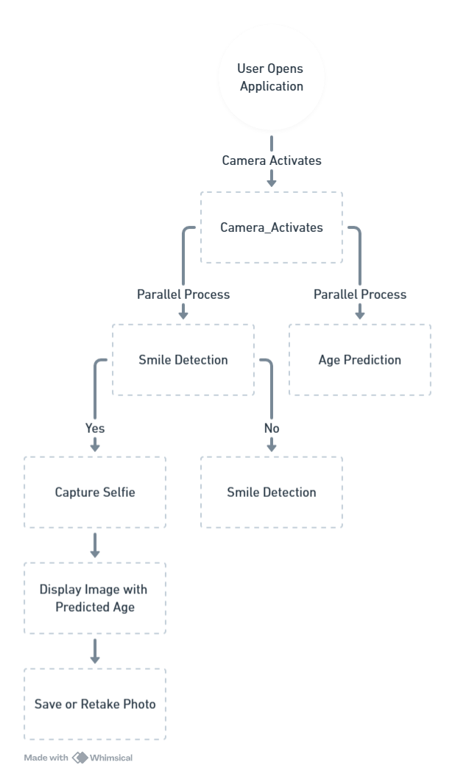

**6. Sample output:**

